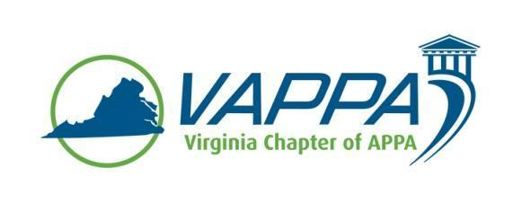

VAPPA Board Meeting Minutes - DRAFT

Date: Wednesday, November 15, 2017 @ 1:30 pm
Place: Teleconference

Welcome/Introductions/roll-call. In attendance:
- John Prengaman (JP)
- Mike Merriam (MM)
- Meghan Johnston (MJ)
- Jim Morris (JHM)
- Julie Bubb (JB)
- Joe Martinez (JMz)
- Duane Swanson (DS)
- Steve Glazner (SGz)
Absent:
- Scott Gesele (SGs)
- Debra Dowden-Crockett (DDC)

Review/approval of minutes

- October minutes were approved

Round table updates

- President (JP)
  - Reaffirmed dates for VAPPA 2018 conference at Hampden-Sydney (March 6-7)
  - Discussed potential sessions for the conference (UVA session with OSHA/FEMA; Drones; other member-driven topics)
  - Discussed options for voting with bylaws (email, simple majority at meetings, would like to move away from strict quorum)

- President-Elect (MM)
  - Discussed SRAPPA, saw good representation from Virginia
  - Proposed possibly setting up a group through LinkedIn as a common interest group for exchanges of ideas (JHM will explore)

- Past President (SGs)
  - Discussed the establishment of a Nominations & Elections committee for the next set of incoming positions to be filled (President-Elect; Treasurer; VP-Education; Business Partner Liaison)

- Treasurer (MJ)
  - No new update

- VP for Communications (JHM)
  - No new update

---JHM Left Meeting----

- VP for Conference Planning (JB)
  - No new update

- VP for Education (DS)
  - Discussed the need to determine a workshop for VAPPA ’18

- VP for Membership (JMz)

- Business Partner Liaison (DDC)

- APPA Liaison (SGz)

Other Chapter business

Meeting Adjourned at 2:15pm

Action Items:

- Meeting minutes – JM

Next Meeting Dates:
Wednesday, December 20, 2017 @ 1:30pm

