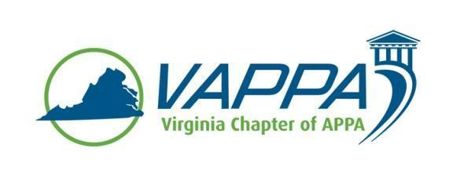

VAPPA Board Meeting Minutes - DRAFT

Date: Wednesday, October 18, 2017 @ 1:30 pm
Place: Teleconference

Welcome/Introductions/roll-call. In attendance:
- John Prengaman (JP)
- Mike Merriam (MM)
- Meghan Johnston (MJ)
- Jim Morris (JHM)
- Julie Bubb (JB)
- Joe Martinez (JMz)
- Debra Dowden-Crockett (DDC)
- Steve Glazner (SGz)
Absent:
- Scott Gesele (SGs)
- Duane Swanson (DS)

Review/approval of minutes

- September minutes were approved

Round table updates

- President (JP)
  - Discussed upcoming SRAPPA conference/meeting
  - Reaffirmed dates for VAPPA 2018 conference at Hampden-Sydney (March 6-7)

- President-Elect (MM)
  - No update
  - Discussed how topics are being received for VAPPA 2018 conference. Several suggested topics were discussed.
    - Drones (MM)
    - Grounds Topics
    - Special Events on a National Scale (JB/MM/JP)
      - Examples: ESPN Game Day (JB); Bicentennial (MM); Presidential Debates (JP)
      - Also possibly compare benefits from national exposure to increased applications and retention

- Past President (SGs)
  - Not present, sent proposed bylaw revisions for review

- Treasurer (MJ)
  - Confirmed that funds were received from George Mason University

- VP for Communications (JM)
  - No new update
  - Discussion regarding adding training outside of Virginia to website (ex. SRAPPA)
    - JM will update site and include additional training

- VP for Conference Planning (JB)
  - Suggested sending out a “Save the Date” note now that dates are locked in

- VP for Education (DS)
  - Not present, did ask to discuss Drive-In Workshop
    - JP indicated that Longwood University offered to host this workshop

- VP for Membership (JMz)
  - Received 2 business partner inquiries
  - Received an inquiry from Allen Gregory with the FBI from Quantico, who is interested in becoming a member

- Business Partner Liaison (DDC)
  - Working to share VAPPA information with k-12 sector

- APPA Liaison (SGz)

Other Chapter business

- Bylaws discussion – four issues mentioned
  - Concern with quorum requirement for voting at meetings (25% of membership) – this will likely be revised due to percentage requirement and logistical concerns
  - Requirement that Treasurer post bonds – changing from “shall” to “may at the direction of the Board”
  - Clarify “Past President” to mean “Immediate Past President”
  - Simplify membership requirement for Associate Members to “Facility Management” (rather than specifying positions)

Meeting Adjourned at 2:15pm

Action Items:

- Meeting minutes – JM

Next Meeting Dates:
Wednesday, November 15, 2017 @ 1:30pm

