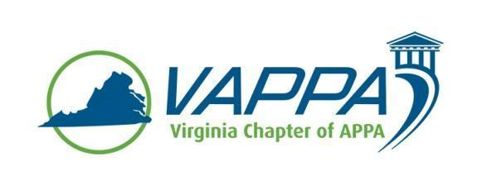

VAPPA Board Meeting Minutes

Date: Wednesday, September 19, 2017 @ 1:30 pm
Place: Teleconference

Welcome/Introductions/roll-call. In attendance:
- John Prengaman (JP)
- Mike Merriam (MM)
- Scott Gesele (SGs)
- Jim Morris (JHM)
- Duane Swanson (DS)
- Joe Martinez (JMz)
- Steve Glazner (SGz)
Absent:
- Meghan Johnston (MJ)
- Julie Bubb (JB)
- Debra Dowden-Crockett (DDC)

Review/approval of minutes

- August minutes were approved

Round table updates

- President (JP)
  - Major issue of concern was to finalize dates for ’18 VAPPA Conference – Hampden-Sydney’s spring break was moved a week, new proposed date is March 6-7, 2018 – Board agreed that if there were no major conflicts, this date would be agreeable. JP to check with DDC
    - Post Meeting Note – JP confirmed with DDC that there were no major conflicts, date for conference has been set for March 6-7, 2018

- President-Elect (MM)
  - No new update

- Past President (SGs)
  - Continuing to work on a run-through of the by-laws
  - Suggested putting a snow plan on the website

- Treasurer (MJ)
  - Not on call, JP ran through treasury numbers that he had available

- VP for Communications (JM for GS)
  - No new update

- VP for Conference Planning (JB)
  - Not on call

- VP for Education (DS)
  - Reminded group to think about Drive-In Workshops based on vendors, Trane has expressed an interest

- VP for Membership (JMz)
  - Received and inquiry from Graham Boyce, who is interested in becoming a business member and possibly presenting at VAPPA ‘18

- Business Partner Liaison (DDC)
  - Not on call

- APPA Liaison (SGz)

Other Chapter business

Meeting Adjourned at 2:01pm

Action Items:

- Meeting minutes – JM

Next Meeting Dates:
Wednesday, ,October 18, 2017 @ 1:30pm
Wednesday, November 15, 2017 @ 1:30pm

