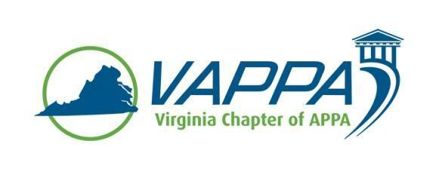

VAPPA Board Meeting Minutes - APPROVED

Date: Wednesday, August 16, 2017 @ 1:30 pm
Place: Teleconference

Welcome/Introductions/roll-call. In attendance:
- John Prengaman (JP)
- Mike Merriam (MM)
- Scott Gesele (SGs)
- Meghan Johnston (MJ)
- Jim Morris (JHM)
- Duane Swanson (DS)
- Joe Martinez (JMz)
- Debra Dowden-Crockett (DDC)
- Steve Glazner (SGz)
Absent:
- Julie Bubb (JB)

Review/approval of minutes

- June minutes were approved without changes
  - JMz requested notice be sent when minutes are posted to the shared file; JHM agreed and will do so

Round table updates

- President (JP)
- Requested a Board count of those who attending the SRAPPA Conference:
  - JP, DDC are planning to attend
  - JMz, MM likely will attend
- Has been reaching out to Council of Independent Colleges in Virginia (CICV)

- President-Elect (MM)
  - No new update

- Past President (SGs)
  - Working on a run-through of the by-laws

- Treasurer (MJ)
  - Waiting on one last check from GMU to add to account

- VP for Communications (JM for GS)
  - 1 new institutional member has been added (from Radford U)
  - 3 new business members signed up via the website
  - Invoices sent via PayPal, MJ copied
  - Website has been updated
  - Several minor issues noted with site, links have been removed

- VP for Conference Planning (JB)
  - Not on call

- VP for Education (DS)
- No update

- VP for Membership (JMz)
- No Update

- Business Partner Liaison (DDC)
  - Reviewed survey results from VAPPA Conference Attendees
  - Regarding 2018 conference, agreed to keep in March

- APPA Liaison (SGz)
  - Reviewed ideas for speakers and sponsor structure from other meetings
  - Offer higher level sponsors provide opportunity for program tracks
  - Possibly have sponsors partner with institutional members

Other Chapter business
- MM asked regarding listserv of members - there is a distribution list, but not a two-way set-up for back-and-forth communication between VAPPA members
  - SGs mentioned possibility of breaking list between institutional and business members

Meeting Adjourned at 2:05pm

Action Items:

- Meeting minutes – JM

Next Meeting Dates:
Wednesday, September 20, 2017 @ 1:30pm
Wednesday, ,October 18, 2017 @ 1:30pm
Wednesday, November 15, 2017 @ 1:30pm

