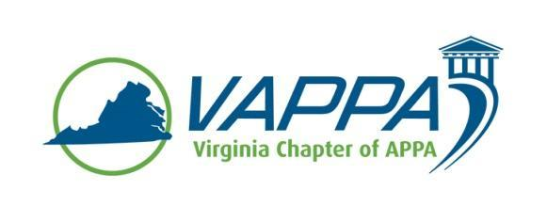

VAPPA Board Meeting Minutes

Date: Wednesday, April 19, 2017 @ 1:30 pm
Place: Teleconference

Welcome/Introductions/roll-call. In attendance:
- Scott Gesele (SGs)
- Mike Merriam (MM)
- Meghan Johnston (MJ)
- Jim Morris (JM)
- Brenda Claudio Cruz (BCC)
- Julie Bubb (JB)
- Duane Swanson (DS)
- Mark Webb (MW)
- Debra Dowden-Crockett (DDC)
- Steve Glazner (SGz)
Absent:
- John Prengaman (JP)
- Greg Sachs (GS)

Review/approval of minutes

- March meetings not reviewed, will review in May with April minutes

Round table updates

- President (SGs)
  - MM has agreed to step in as President-Elect
  - One other candidate was discussed as a possible other candidate, may also be willing to step in as VP for Membership
    - JM mentioned that there is a slight chance he may move out of state, so Board may want to keep this candidate on reserve in case that spot becomes vacant
  - SGs sat in on SRAPPA president’s conference call, noted that they are a strong advocate for the state chapters and willing to help as needed
    - There was some discussion with SRAPPA about VAPPA potentially establishing their own scholarship for CEFP and EFP.

- President-Elect (MM)
  - No update, other than gratitude from the Board members present for MM for stepping in to this role

- Treasurer (MJ)
  - MJ noted that it appears JP got checks, as this was included in IRS submissions

- VP for Communications (JM for GS)
  - GS had transition call with JM in March

- VP for Conference Planning (JB)
  - No update other than what Brenda presented

- VP for Education (DS)
  - DS trying to get current number of attendees for drive-in workshop in May from Corey (APPA)
    - Agreed to act as point of contact for BCC with the speaker for the session

- VP for Membership (MW)
  - Will reach out to schools not represented at the conference
    - DDC agreed to help with this

- Business Partner Liaison (DDC)
  - DDC agreed to consult with the SPMA representative in Atlanta, Georgia regarding their conference per request from SGz
  - DDC indicated that she will reach out to higher education and K-12 institutions (via VSPMA) not represented at the conference

VAPPA Conference (May 31-June 1 @ GMU)
- BCC noted that numbers are essentially the same as in March
  - Only three registrants requested refunds
  - One sponsor (ApCo) withdrew, but was replaced by another (Stanley/Black & Decker at the same level
  - Approximately $26,0000 net is expected from the conference ($16K profit + $10K reimbursement of VAPPA funds)
  - Because of the change, two breakout sessions are being moved to a nearby building
    - Schedule is being adjusted accordingly
    - SGs agreed that it would be prudent to reprint the program rather than insert an addendum with the changed – other Board members concurred, none noted any objection – cost will be ~$700.
      - BCC noted that she will attempt to obtain additional sponsorship for the additional printing
  - The drive-in workshop was relocated to another area approximately 5 minute walk from the main conference area
  - SGs requested to make sure that all websites for the conference have matching information
  - SGs will get the most current registration and sponsor list from BCC and then send an email to those contacts not already registered

Other Chapter business
- None noted

Action Items:

- Meeting minutes – JM/GS
- DS to get number of registrants for drive-in workshop to DS
- BCC to send list of current attendees to SGs who will send to VAPPA board.
- MW to work together to reach out to schools (higher education) regarding the conference
- BCC and DDC to work together to reach out to K-12 schools (via VSPMA) regarding the conference

Next Meetings Dates:
Wed, May 17, 2017 @ 1:30
Mon, May 31, 2017 @ GMU VAPPA ‘17

